PROJECT REPORT: GAMES DATASET ANALYSIS

1. INTRODUCTION
Video games industry is growing rapidly. This project aims to analyze games data to find trends in sales, genre, and platforms.
2. PROBLEM STATEMENT
To clean and analyze the raw games dataset and visualize insights.
3. OBJECTIVES
To clean the dataset (remove null values)To find top selling gamesTo analyze Genre and Platform wise distributionTo create visualizations
4. SYSTEM REQUIREMENTS
Software: Python 3.9, VS Code
Libraries: pandas, numpy, matplotlib, seaborn
5. METHODOLOGY
Step 1: Import Libraries
Step 2: Load Dataset (csv file)
Step 3: Data Cleaning
Step 4: Exploratory Data Analysis (EDA)
Step 5: Data Visualization
6. CODE EXPLANATION

df.info() - dataset details
df.isnull().sum() - null values check
df.dropna() - nulls remove
sns.barplot() – graphs

7.Results
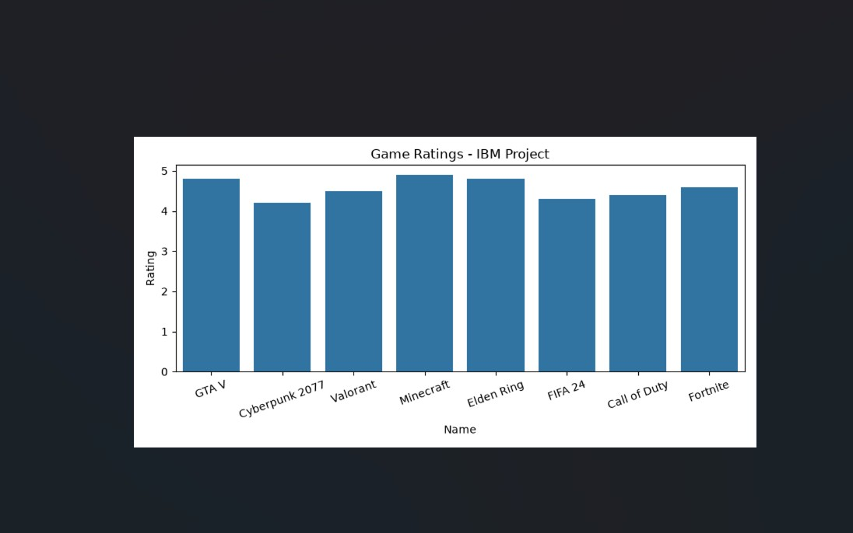

8. CONCLUSION
In this project we successfully analyzed games dataset and found that Action genre is most popular and PS2/PS4 platforms have high sales.

